Wildlife Tracker

USER MANUAL

A fully remote wildlife researching system

**Version 1.0**

**November 2022**

Table of Contents

1.0 GENERAL INFORMATION 3

1.1 System Overview 3

1.2 Authorized Use Permission 3

1.3 Points of Contact 3

2.0 SYSTEM FEATURES 4

2.1 Web Application 4

2.2 Tracking Device 4

3.0 QUICK START GUIDE 4

3.1 User Registration 4

3.2 Login 6

3.3 Change Your Password 7

3.4 User Dashboard 9

3.4.1 Add your device to your profile 9

3.4.2 See the photos captured by your device 11

3.4.3 Observe where your device located 11

3.4.4 Technical Support 12

3.4.5 Logout 13

4.0 Tracking Device 14

4.1 Parts identification of the tracking device 14

4.2 Instructions to use the device 15

4.3 Instruction to charge the device 15

4.4 Technical Specifications 15

5.0 Service Information 15

5.1 Technical Support and Service 15

5.2 Installation and Operation 15

# 1.0 GENERAL INFORMATION

## 1.1 System Overview

The wildlife tracking system is an application that allows you to conduct your research remotely. You can monitor behavior of animals real-time from anywhere in the world using this system.

This manual will help you find your way around the various features offered by Wildlife Tracker. Refer this manual to make the most of what Wildlife Tracker has to offer and to turn tedious wildlife researching into an easy and smooth task. First, let’s begin with a few notes on how to use the Wildlife Tracker User Manual. If you are reading this manual in PDF format,

* The Table of Contents page contains a brief overview of the manual’s contents, allowing you to browse through the chapter headings and page numbers. Click on the page number to quickly access a desirable topic.
* Use the search function in your PDF viewer to find a specific topic you would like to learn about, e.g., “Register” or “Change Password”.

## 1.2 Authorized Use Permission

The Wildlife Tracking system is not available to the general public. Only certified wildlife researchers are allowed to use the system. You need to go through a registration process in order to use the system. You have to use your account credentials to login to the system after registration to observe data collected from your device.

## 1.3 Points of Contact

For additional information, please contact the admin panel.

|  |  |
| --- | --- |
| Department of computer Engineering,  Faculty of Engineering,  University of Peradeniya,  Sri Lanka. | Tel: +94 703 761 949  Tel: +94 719 777 032  E-mail: [wildlifetrackeruop@gmail.com](mailto:wildlifetrackeruop@gmail.com) |

# 

# 2.0 SYSTEM FEATURES

## 2.1 Web Application

You can monitor your tracking devices only through the provided web application. Use this link to access the web application (<www.wildlifetracker.com>). First you have to register in the system. We have provided the guidelines for registration in a section in this document. After the registration you have to login to the system. Then you can observe the images captured by your devices through the web application. Also, the locations of your devices are displayed in a map.

## 2.2 Tracking Device

The tracking device can sense motions within 7 meters. When a motion is detected it will capture a photo. You can see these photos through web application without reaching the research area. There is an internal memory provided in the SD card to avoid data losses due to connection issues. Also, a solar panel is provided with the device to recharge the batteries using solar power. Special design decisions are taken to make sure that device operates longer period of time with battery power. One user can have multiple devices. The user can monitor all of his devices through the web application.

# 3.0 QUICK START GUIDE

## 3.1 User Registration

All users of the system need to register in the system before use it. After successful registration a user can minor his tracking device through user dashboard.

Open your browser, key the web address below and press Enter.

<https://www.wildlifetracker.com>

The new Wildlife Tracker home page will display.

1. Click on ‘Get Started’ button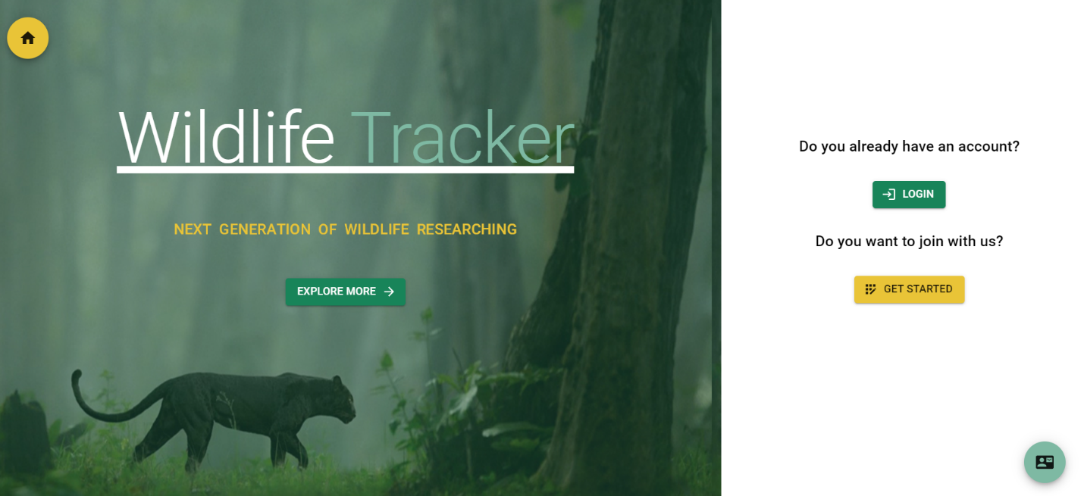

1

The registration form displays as shown below.

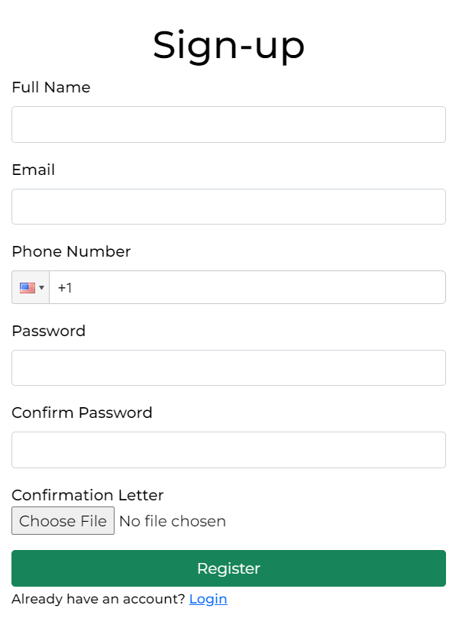

3

2

1. Fill the form.
2. Enter a valid email address. You cannot have two accounts created using the same email address.
3. Password must be at least eight characters (at least one letter and one number). Note: Passwords are case sensitive. Don’t forget the password and email address you used, they are required to login to the system.
4. The confirmation letter is a must to register in the system. The document must include information to prove that you are authorized to conduct wildlife research. Note: Only JPEG or PNG formats are allowed.
5. Click ‘Register’ button.

On successful registration, the message below is prompted.

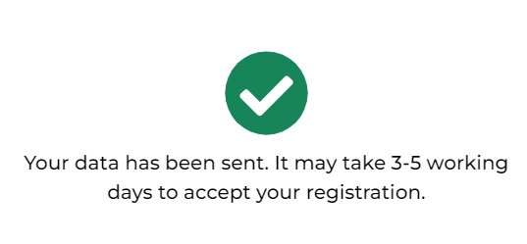

You need to wait until one of our administrators look into your registration details and approve your registration to access the site. This will take maximally five working days. You will receive an email when an administrator approved or rejected your registration

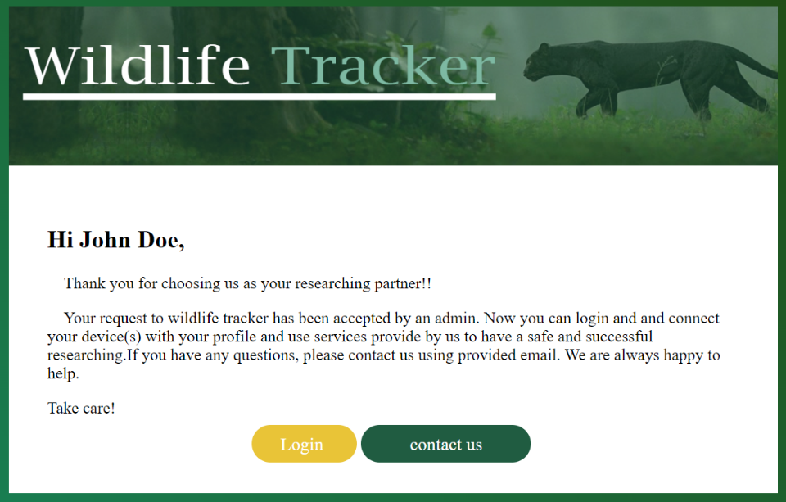

4

1. Click the ‘login’ button to login to your dashboard.

## 3.2 Login

Open your browser, key the web address below and press Enter.

<https://www.wildlifetracker.com>

The new Wildlife Tracker home page will display.

1. Click on ‘Login’ button



1

The login form displays as shown below.

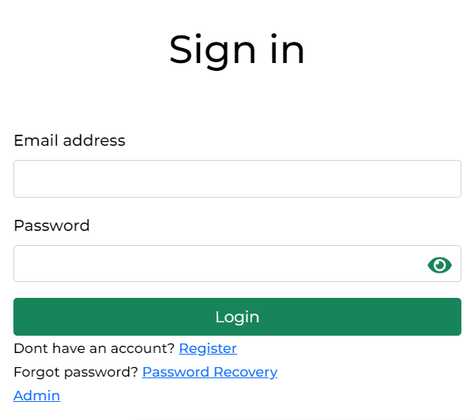

2

3

1. Type the Email address and Password you have entered in the registration form.
2. Click ‘Login’ button.

On successful login you will direct to user dashboard. From here you can monitor your devices.

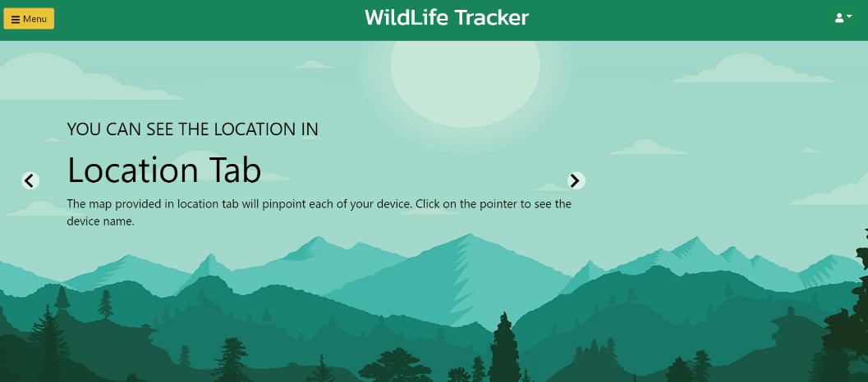

## 3.3 Change Your Password

Open your browser, key the web address below and press Enter.

<https://www.wildlifetracker.com>

The new Wildlife Tracker home page will display.

1. Click on ‘Login’ button



1

The login form displays as shown below.



2

1. click in the ‘password Recovery’ link.

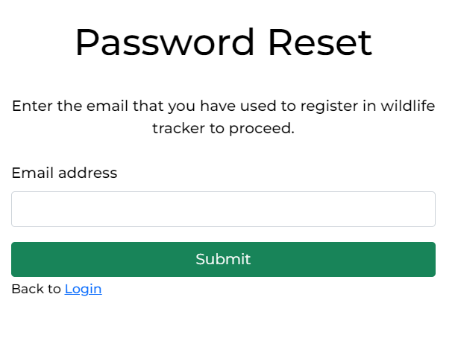

3

4

1. Enter your email address that you have used to register in the system.
2. Click ‘Submit’ button.
3. You will receive a password rest email to the email address you have just submitted.
4. 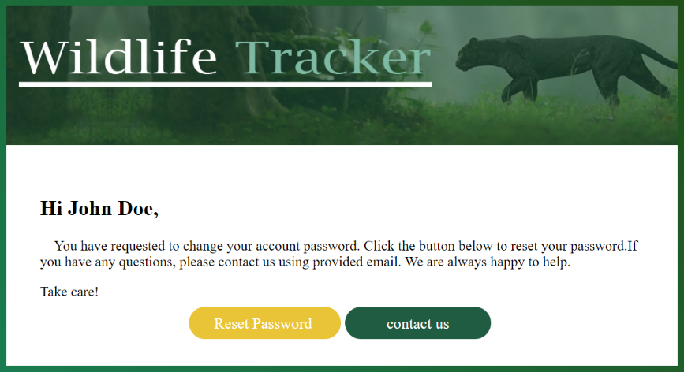

6

1. Click on the ‘Reset password’ button.

The following form is displayed.

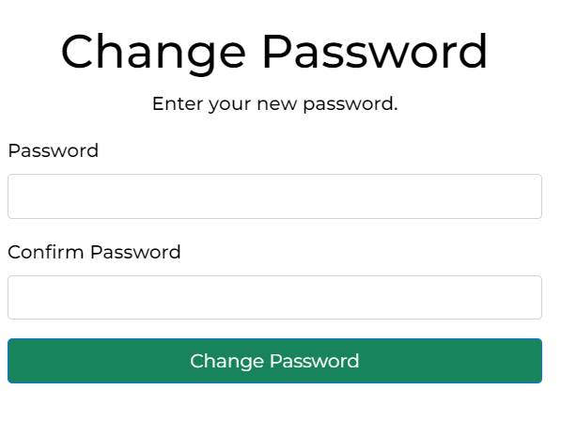

10

9

8

1. Type your new password in the field “password”.
2. Type the same password un the field “confirm password”.
3. Click the ‘change password’ button.

If the Password is reset, following message is displayed.

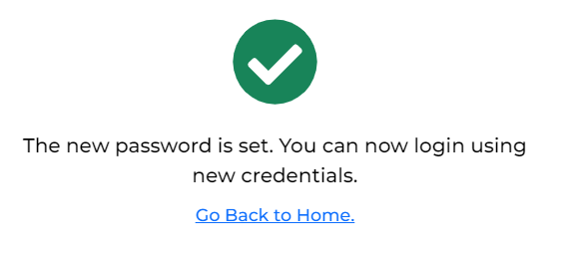

## 3.4 User Dashboard

### 3.4.1 Add your device to your profile

To get data from your device to your profile, you need to add the device to your device list. To do so, you need the serial number and the password of the device we have provided to you with the device. You cannot use serial number/password of another device to add your device to your profile.

Note: Do not lost the serial number/password of your device. And do not share this serial number/password with other parties.

1. Login to user dashboard.
2. Click the ‘Menu’ button to open side menu.

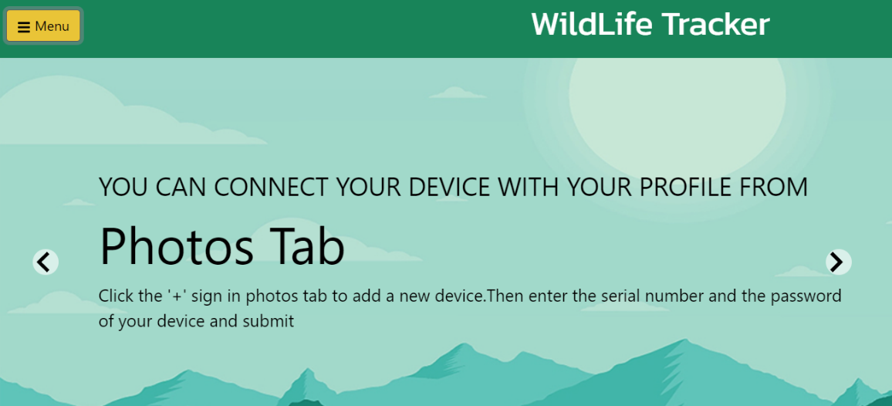

2

1. Go to ‘Photos’ tab.

3

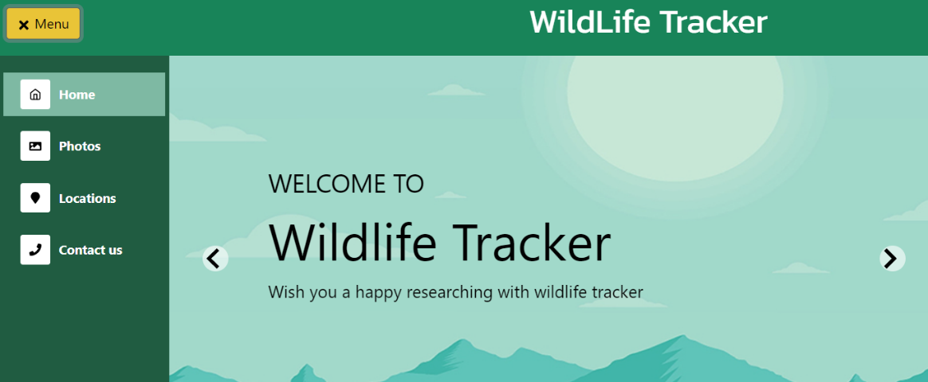

1. Click the ‘+’ button.

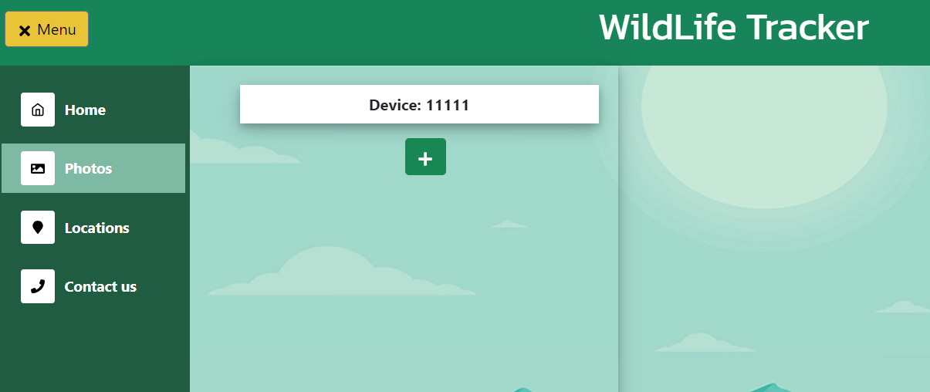

4

1. Enter the given serial number and password in displayed form.

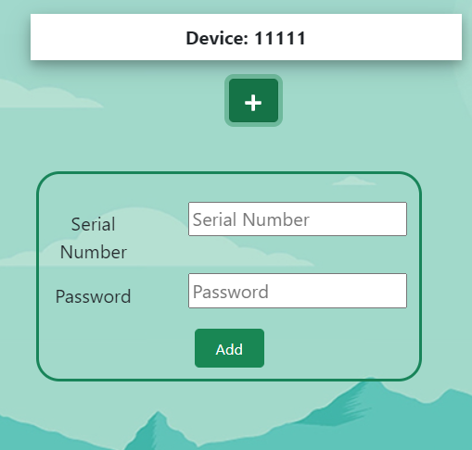

5

1. Click ‘Add’ Button.

### 3.4.2 See the photos captured by your device

1. Login to user dashboard.
2. Click the menu button and go to photos tab.

The list of devices that you have added to your profile is displayed here.

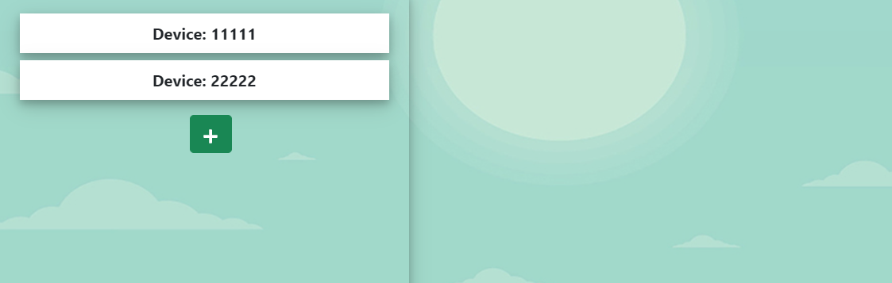

2

1. Click a device to see the photos captured by that device.

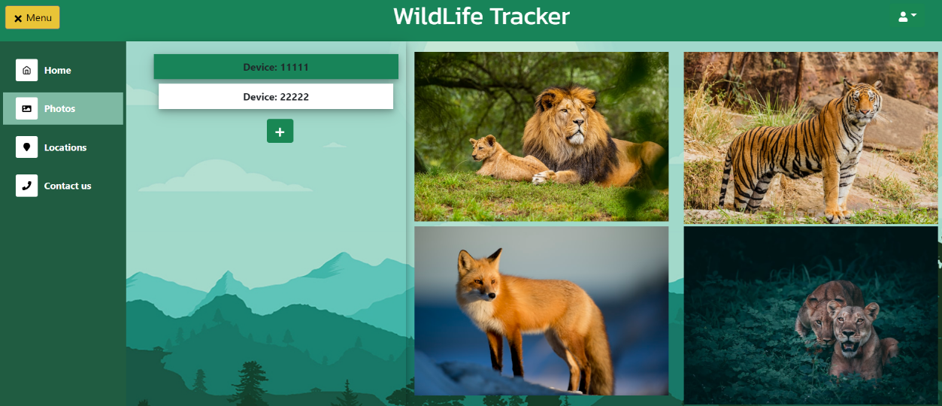

3

### 3.4.3 Observe where your device located

1. Login to user dashboard.
2. Click the ‘Menu’ button to open side menu.



2

1. Go to ‘Location’ Tab.



3

Locations of the devices which are listed under your profile is displayed in a map.

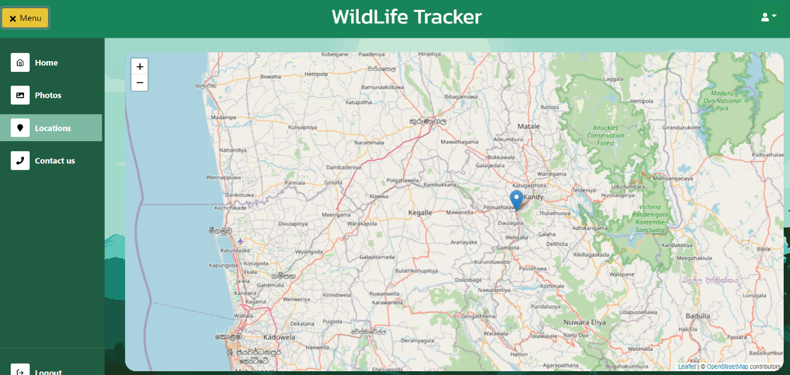

### 3.4.4 Technical Support

1. Login to user dashboard.
2. Click the ‘Menu’ button to open side menu.
3. Go to ‘Contact Us’ Tab.



3

From this tab you can get the contact details of our team to have technical support. We are happy to help you. Feel free to contact us if you face any issue while using the system. Also, we appreciate your feedbacks to improve our system to give you a better experience.

### 3.4.5 Logout

1. Open the side menu by clicking the ‘Menu’ button.
2. Click the Logout button to log out from the dashboard.

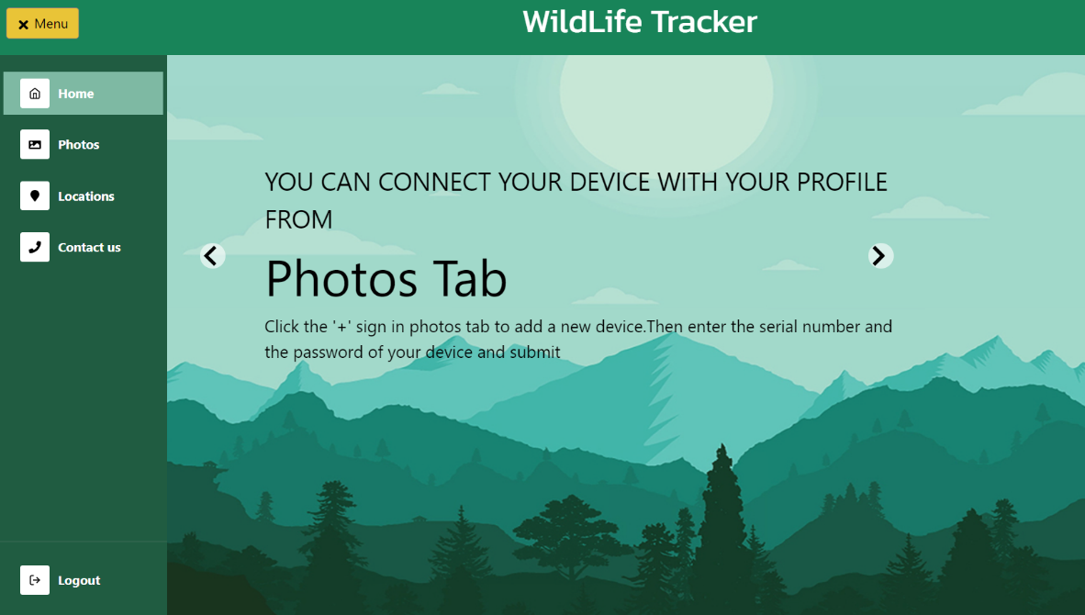

2

Note: After you logout from the system you need to login again to access the user dashboard.

# 

# 4.0 Tracking Device

## 4.1 Parts identification of the tracking device

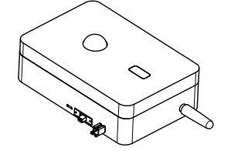

LED indicator

Solar Panel Port

ON/OFF Switch

Charger Port

Flasher

GPRS Antenna

Camera

PIR Motion Sensor

|  |  |  |
| --- | --- | --- |
|  |  |  |

|  |  |
| --- | --- |
| Accessories | |
| Portable solar panel | Charger |

## 

## 4.2 Instructions to use the device

1. First of all, you need to add your device to device list of your profile. Follow the instruction given in section 3.4.1, to add the device.
2. Turn on the device by sliding the switch to ON position.

The blue color LED should light up if the device is on.

1. Place the device in your researching area.
2. Plug the solar panel to solar panel port in the device and place the solar panel so that its surface is opened to sunlight.
3. Now you can monitor your device through the web application. Login to your profile and observe what your device captured for you.

## 4.3 Instruction to charge the device

1. Use only the charger provided with the device to charge it.
2. Connect the charger to charger port and plug it to power supply.

Note: Do not try to plug a charger to solar panel port. Make sure that the device is turned off before plunging to the power supply.

## 4.4 Technical Specifications

|  |  |
| --- | --- |
| Rated power supply | 220v ~ 50Hz |
| Overall dimensions | 155 mm * 88 mm * 59 mm |
| Maximum transmission speed | 85.6 kbps |
| Minimum transmission speed | 9.05 kbps |
| Battery capacity | 18650mAh |
| Maximum camera resolution | 1600*1200 |
| Storage | can insert SD card up to 64GB |
| Sim card | Micro sim |
| Weight | 400g |

# 5.0 Service Information

## 5.1 Technical Support and Service

For technical support, please mail to: [wildlifetrackeruop@gmail.com](mailto:wildlifetrackeruop@gmail.com)

## 5.2 Installation and Operation

Our professionals guide you through the installation and operation of your new product so that it is efficiently operational in the minimum amount of time.